Multiple-choice section – choose the correct answer

Question 1 [4.6] [10A]

When using the quadratic formula to solve 5x2 = 3x – 7, the values of a, b, c are respectively:

A 5, 3, -7 B 3, -7, -5 C 3, -7, 5 D 5, -3, 7

Question 2 [4.5] [10A]

The factors of 6x2 – x – 15 are:

A (2x – 3)(3x + 5) B 3(2x − 1)(x + 5) C (2x + 3)(3x - 5) D (6x – 5)(x + 3)

Question 3 [4.6] [10A]

Which equation has solutions 7 and -0.5?

A (x – 7)(2x + 1) = 0 B (x + 7)(x – 0.5) = 0

C (2x – 1)(x – 7) = 0 D (2x – 7)(x + 0.5) = 0

Question 4 [4.6] [10A]

The quickest way to solve (2x – 3)(4x + 5) = 0 is by:

A completing the square B using the quadratic formula

C using the null factor law D multiplying the two numbers

Question 5 [4.1]

Solving x2 – 14x – 72 = 0 for x gives:

A 8 and -9 B 8 and 6 C 18 and -4 D -18 and 4

Question 6 [4.3]

The values of h and k in the expression  are, respectively:

A  B  C  D 

Question 7 [4.3]

The solution to x2 + 3x + 1 = 0 is:

A  B  C  D 

Question 8 [4.2]

Completing the square to factorise x2 + 8x – 3 will give:

A (x + 4 + )(x – 4 – ) B (x + 4 + )(x + 4 – )

C (x – 3)(x + 1) D (x + 3)(x + 5)

Question 9 [4.4]

The turning point (x, y) of the graph of  is:

A (6, -77) B (-6, -77) C (6, -5) D (-6, -5)

Multiple-choice results: ___ / 9

Short answer section

Question 10 3 marks [4.1]

Use the null factor law to solve the equation 2x2 – 20x + 18 = 0.

Question 11 5 marks [4.6] [10A]

(a) Solve 4x2 – 28x + 49 = 0 for x.

(b) If 4x2 – 28x + 49 represents an area of 121 cm2 of a square, calculate the possible values of x.

Question 12 5 marks [4.2, 4.3, 4.4]

Consider the parabola y = x2 + 3x + 1.

(a) Complete the square to express the equation in the form y = (x − h)2 + k.

(b) Write the coordinates of the turning point.

(c) Find the coordinates of the x-intercepts in exact form.

Question 13 3 marks [4.6] [10A]

Solve 7y4 – 18y2 + 8 = 0 by first splitting the middle term to factorise.

Question 14 3 marks [4.2]

Factorise 3x2 – 12x – 6 by completing the square.

Question 15 2 marks [4.6] [10A]

Use the quadratic formula to determine whether the following equations have real solutions for x. You need to give reasons for your answers, but you do not need to solve the equations.

(a) 2x2 – 7x – 8 = 0

(b) 5x2 – 3x + 6 = 0

Question 16 4 marks [4.4]

Write the equations of two parabolas that have the same turning point as y = 5(x – 4)2 – 6.

(a) in the form y = ax2 + bx + c

(b) in the form y = a(x – r)(x – s)

Question 17 4 marks [4.6] [10A]

The concrete area of a rectangular outdoor space is to be 35 m2, the length is (4x – 1) m and the width is (2x + 1) m. Find the dimensions of the concrete area.

Question 18 5 marks [4.4]

If the coordinates of the turning point for the graph with equation  are (-3, 7):

(a) state the value of c

(b) show that b = 3a.

(c) explain why the value of a can never equal zero.

Question 19 4 marks [4.1]

The distance d metres that an object moves from its original position after t seconds is given by  
d = ut +at2, where u is the initial velocity and a is the acceleration.

(a) Write the equation for u = 30, a = 10 and d = 200.

(b) Solve the equation in part (a) for t.

(c) When will the object be 200 m from its original position?

Question 20 6 marks [4.4]

(a) Sketch the graph with equation y = (x + 5)(x – 3).Mark the x- and y-intercepts and the turning point.

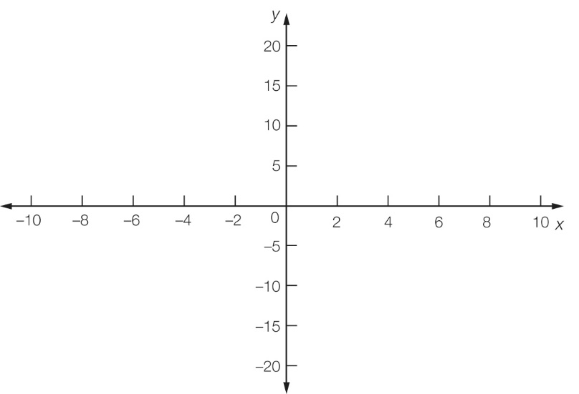

(b) For what values of p and q is the following statement true? Give reasons.  
The graph of y = (x – p)(x – q) will pass through the origin.

Question 21 4 marks [4.4]

(a) Write the equation y = x2 + 2(a – 3)x + a2 in simplest turning point form.

(b) If the x-coordinate of the turning point of y = x2 + 2(a – 3)x +a2 is 8, find the y-coordinate.

Question 22 2 marks [4.2, 4.4]

Explain how the turning point of a parabola is found from the equation y = x2 + 2ax + a2+ b.

Short answer results: ___ / 50

Extended answer section

Question 23 5 marks [4.4]

A rocket launcher, which can be programmed to follow a variety of paths, is placed in a hole in the ground so that the missile appears to come out of the ground at zero height.

The launcher is initially set to follow the path h = -3d2 + 240d, where h represents the height of the rocket in metres and d is the horizontal distance travelled in kilometres.

(a) Find the distance between the launch site and the target.

(b) Find the maximum height reached by the rocket.

(c) Sketch the pathway of the rocket on the set of axes below.

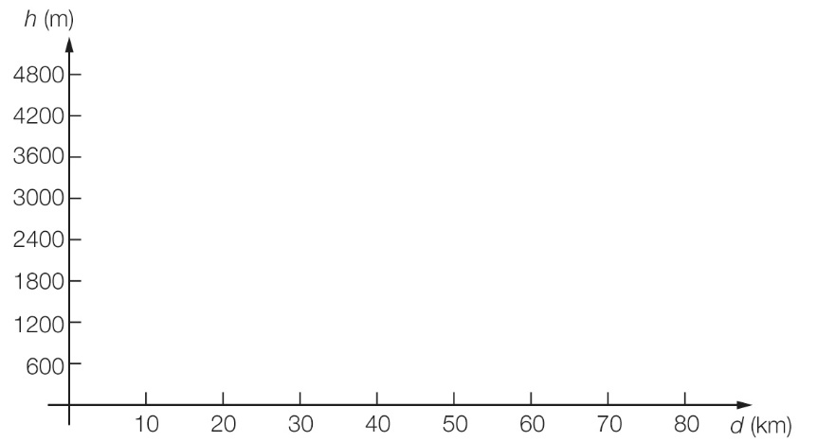

Question 24 5 marks [4.1]

A circle of radius 3R cm is cut out from a square of side length 4x cm.

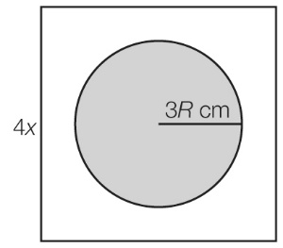

(a) Write the expression for the area of the square that remains when the circle is cut out.

(b) Factorise the expression in part (a).

(c) (i) For what values of x is the expression zero?

(ii) Explain why these values are not realistic in terms of representing the shaded area.

Question 25 9 marks [4.1, 4.3, 4.4]

The equation y = 10x – x2 gives the height y metres of a projectile at time x seconds after it has left the ground.

(a) Complete this table for the values of x and y.

|  |  |  |  |  |  |  |  |  |  |  |  |
| --- | --- | --- | --- | --- | --- | --- | --- | --- | --- | --- | --- |
| x | 0 | 1 | 2 | 3 | 4 | 5 | 6 | 7 | 8 | 9 | 10 |
| y |  |  |  |  |  |  |  |  |  |  |  |

(b) Use the table to help you plot points to show the path of the projectile on the grid below.



(c) State the turning point of the graph.

(d) Find the x- and y-intercepts of the graph.

(e) Complete the square to find, correct to 2 decimal places, the two times when the projectile reaches a height of 6 m.

(f) Explain why there are two values found in part (e).

(g) Explain why there are no solutions where y = 30.

Question 26 4 marks [4.2, 4.3, 4.4]

Rajit hits a golf ball so that its path is given by the equation h = 0.002x(100 – x) where h metres is the height of the ball and x metres is the horizontal distance.

(a) What is the highest level the golf ball reaches?

(b) Find the horizontal distance between where the golf ball is hit and where it lands assuming that the fairway is flat.

(c) Rajit hits the ball into the path of some trees. Will it clear a tree that is 4 m high and 30 m from where he hit the ball?

Extended answer results: ___ / 23

TOTAL test results: ___ / 82